28 Editors - Asset Manager
Detailed table of content 1
Asset Browser 3
How to 3
Header 4
Header - View menu 4
Header - Select menu 5
Header - Tools and Options 5
Tool shelf 8
Sidebar 8
Files context menu 9

Detailed table of content

Detailed table of content
Detailed table of content 1
Asset Browser 3
How to 3
Header 4
Header - View menu 4
Source List 4
File Path 4
Area Menu 4
Horizontal Split 4
Vertical Split 4
Duplicate Area into new Window 5
Toggle Maximize Area 5
Toggle Fullscreen Area 5
Header - Select menu 5
Box Select 5
Inverse 5
None 5
All 5
Header - Tools and Options 5
Asset Library chooser 5
Built-in 5
Custom 6
Refresh 6
Display Mode 6
Size 6
Recursion 6
Sort by 6
Reverse Sorting 6
Search 7
Filter 7
Show Hidden 7
Toggle Region 7
Tool shelf 8
Sidebar 8
Asset Name 8
Preview Panel 8
Load Custom Icon 8
Generate Preview 8
Details Panel 8
Description 8
Tags Panel 8
Tags List 9
Drag handler 9
Search 9
Files context menu 9
Back 9
Forward 9
Go to Parent 9
Refresh 9
Increase Number 9
Decrease Number 9
Rename 9
Delete 10
New Folder 10
Add Bookmark 10
Display Mode 10
Display Size 10
Recursion 10
Sort 10

Asset Browser
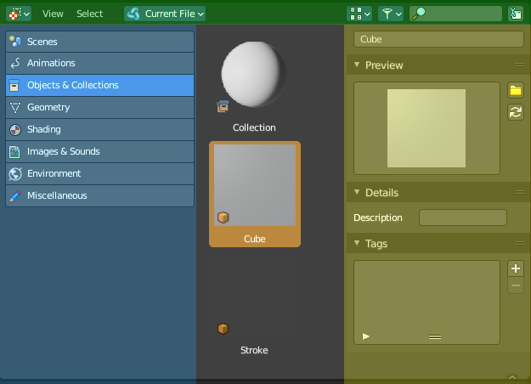
The Asset browser is an explorer dialog that allows you to store assets, and reuse them at a later point.
Assets can be everything. Objects, scenes, grease pencil strokes and so on.
The asset browser is still WIP. With quite a few quirks and oddities. And most probably lots of changes yet to come.

The asset browser interface is divided into several areas.
Header (green)
Categories (blue)
Sidebar (yellow)
Content area ( no color)

How to

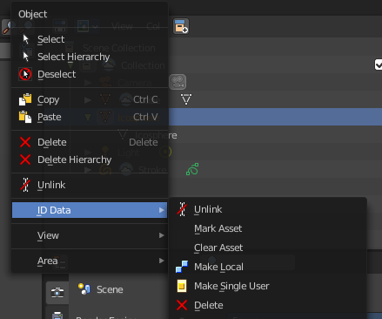
Please keep in mind that this is an early implementation. So this will most probably change.
To insert or remove an asset you currently need to go across the ID Data menu in the outliner. Right click at the object or data or collectoin that you want to insert, have a look for the ID Data menu, and choose Mark Asset.

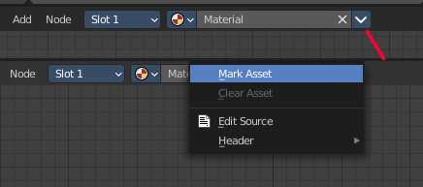
When it is something like a material or a texture, then you can also right click at the menu in the data prop. This will also reveal a menu where you can add or remove the asset.

Dragging items into the browser is currently not supported. This fails in the case of the 3d view by the mouse that wraps around the 3d view. And is that way limited to the 3d view as long as you drag an object around.
The other direction works though. You can drag assets from the browser into the 3d view.

Header

There are several tools in the header to find. Two menus, and a few options.

Header - View menu

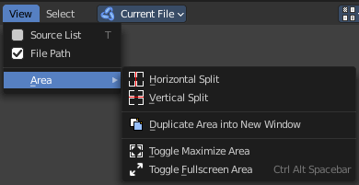
The view menu contains view related functionality.

Source List
Shows or hides the tool shelf at the left side.

File Path
Please ignore. This entry is a bug. The asset browser shares the code with the file browser.

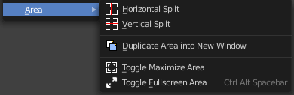
Area Menu
Area is a menu with window related settings.

Horizontal Split
Splits the editor horizontally into two editors.

Vertical Split
Splits the editor vertically into two editors.

Duplicate Area into new Window
Creates a floating window out of the current editor.

Toggle Maximize Area
Displays the editor maximized with menus.
To return to split view press hotkey Ctrl Up Arrow, or reuse the menu item in the View menu.

Toggle Fullscreen Area
Displays the editor maximized without menus.
To return from the full screen view press hotkey Alt F10, or use the little button that appears up right when you move the mouse in this corner.

Header - Select menu

Select functionality.

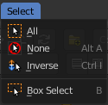
Box Select
Allows you to box select files. Note that this is an old obsolete operator. You don't need to press the hotkey anymore for box select.

Inverse
Inverts the selection.

None
Select none.

All
Select all.

Header - Tools and Options

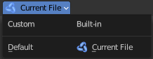
Asset Library chooser
Here you can choose what asset library to use.

Built-in
Uses the current Blend file as the asset library. All assets are stored into the current blend file. And this means that when you remove objects from the scene, then the assets in the assets library will also vanish.

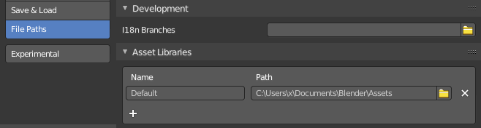
Custom
Uses the blend file in the path that is defined in the user preferences as the asset library.
Note that this feature is not fully implemented yet. Changing the path here leads to an error. And adding a second path does simply nothing. At the moment youu need to create a Blender/Assets/ folder structure in your documents directory by hand, and store a blend file there. This blend file is then used as the asset libary.
Working with more than one blend file is currently not supported.

Refresh
With a custom library a refresh button appears. Refreshes the file list.

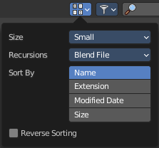
Display Mode

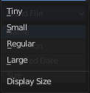
Size
The displays size of the assets. Note that you cannot turn to list display here. Just big icons.

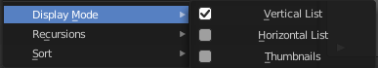
Display as list can be done in the files context menu, which can be called with a right click in the view. Have a look at the display mode menu item.

Recursion
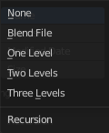
Adjust how deep the explorer should dig. Normally it just lists the content of the currently selected directory. But it is also possible to list the content of the folders three levels lower.
The recursion direction is always downwards. Default is None.

Sort by
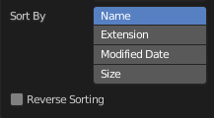
Sort the files by chosen method. The methods are self explaining.

Reverse Sorting
Reverts the sorting direction.

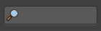
Search
Name Filter. Allows you to search for specific files and folders.

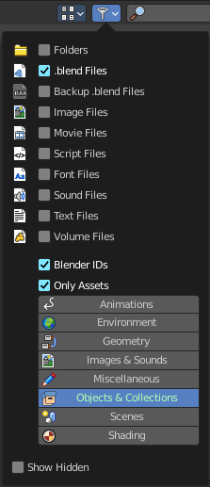
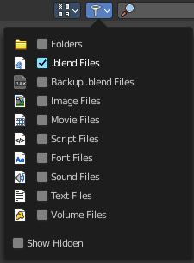
Filter
Allows you to filter the assets library in various ways. The menu items should be self explaining.
When the asset libary is custom then you will get more options.

Show Hidden
Shows hidden Dot files.
This is a Unix feature. Unix systems like Linux or Mac hides files from file browsers and explorers by having a dot before the file. A good example is the .htaccess file at servers. Show hidden Dot Files makes such files visible to the file browser.

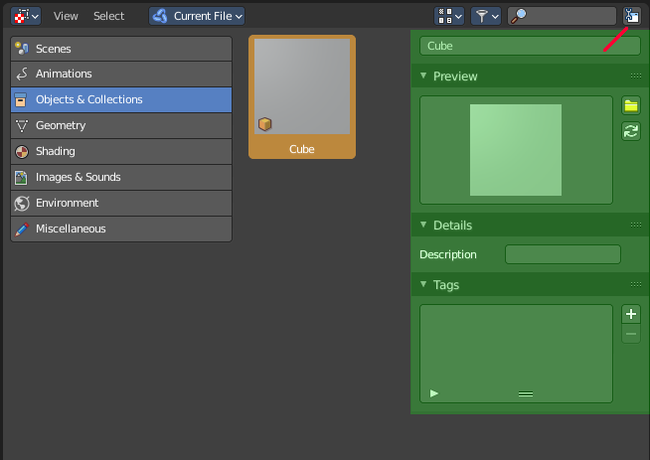
Toggle Region
Toggles the sidebar at the right. The sidebar contains various im- and export settings for the single file types.

Tool shelf
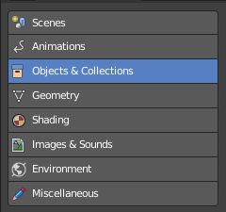

The toolshelf shows the different categories that you can use to store your assets.

Sidebar

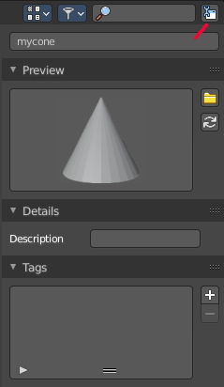
At the right side you will find the Sidebar. It is usually hidden. But can be revealed by a click at the litte triangle button, or with a click at the Toggle Region button in the header at the right.

Asset Name
The name of the asset. Here you can also rename the asset. Note that the name of the asset in the view does not refresh immediately at the moment. You can force a refresh of it in the Preview panel by clicking at the Generate Preview button

Preview Panel
A preview of the asset. By default the same image that you see in the view when you create the asset.

Load Custom Icon
Opens a file browser where you can choose a custom icon for this asset.

Generate Preview
Genereates a preview icon from the content. Note that this will reset the custom icon.

Details Panel

Description
Enter a description for this asset.

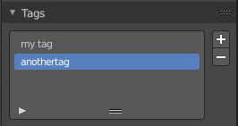
Tags Panel
Enter custom tags for this asset. This tags have currently no function.

Tags List
The list of the current tags.

Drag handler
Allows you to resize the list.

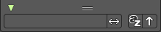
Search
Search the list. This search can be expanded by clicking at the little triangle button down left.

Files context menu

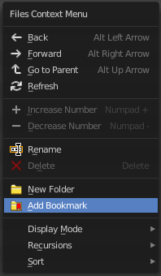
When you right click into the view then a files context menu opens. This menu comes from the File browser, and contains a few menu items that are not vaild for the asset browser. Like create a folder.

Back
Go to previous folder.

Forward
Go to next folder.

Go to Parent
Go upwards the hierarchy by one.

Refresh
Refresh the file list.

Increase Number
Increases the number at the selected data file in the file name edit box.

Decrease Number
Decreases the number at the selected data file in the file name edit box.

Rename
Rename the selected item.

Delete
Delete the selected item.

New Folder
Add a new folder.

Add Bookmark
Adds a bookmark in the file browser tool shelf in the Favourites panel.

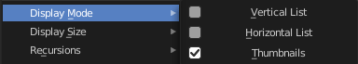
Display Mode
Display the content as a list or as icons.

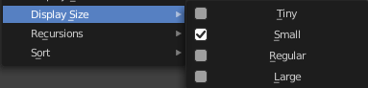
Display Size
Set the display size of the file browser to four predefined sizes.

Recursion
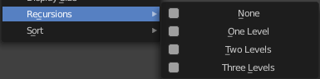
Recursion is a menu where you can adjust how deep the explorer should dig. Normally it just lists the content of the currently selected directory. But it is also possible to list the content of the folders three levels lower.
The recursion direction is always downwards. Default is None.

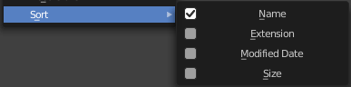
Sort
Sort the content by the chosen method.

